REQUIREMENTS FOR THE SUBMITTED PAPERS
The recommended size of the article, including references and graphic material, should not exceed 10 pages typed in MS Word.
The references to the literature and the bibliographic list are required. Annotation should not exceed 600 characters including spaces. If article is in Belarusian or Russian, it title and the abstract in English should be added.
Tables and illustrations should correspond to the width of the main text. Tables should be decorated with standard MS Word tools. The font size used in tables should be not less than 10 pt.
Literature citation in text should be presented as author name and year of publication in parentheses, for example, (Ivanov 1992), (Ivanov & Petrov 1992), (Ivanov et al. 1992), (Ivanov 1992, Ivanov & Petrov 1995).
References in the bibliography are listed in alphabetical order. Design of references is given below:
Books:
Ivanov A.A. 2019. Book title. 213 p.
Ivanov A.A., Petrov I.I. 2019. Book title. 213 p.
Articles:
Ivanov A.A. 2019. Article title // Jornal title. Vol. 27. No. 2. P. 13–17.
Ivanov A.A., Petrov I.I. 2019. Article title // Jornal title. Vol. 27. No. 2. P. 13–17.
Articles should be saved as *.doc file. File name must contain authors’ (author’s) name separated by a lower underscore (for example, ivanov_petrov). Figures should be in *.jpg format. Please, duplicate figures and tables from the article in separate files and send them to the e-mail of the Organizing Committee entomology.belarus@gmail.com
General requirements to the article:
- Text should be in Times New Roman, type size 12;
- Interline spacing – 1.5 lines;
- All borders – 2 cm.
Example and some requirements for design of the article are indicated in the template below.
Articles that do not meet the requirements will be sent to the authors back for revision. Organizing Committee reserves the right for rejection articles if they do not correspond to subjects and conditions of the Conference.
UDC: (12 pt., left alignment, not indented)
(empty string, 12 pt.)
Article title (14 pt, capital, bold, not indented, centered alignment)
(empty string, 12 pt.)
Dashkevich M.M. (12 pt., italic, not indented, centered alignment)
(empty string, 12 pt.)
e-mail: (italic, not indented, centered alignment)
(empty string, 12 pt.)
Abstract (12 pt, bold, italic, not indented, centered alignment)
(empty string, 12 pt.)
Text, text, text… (12 pt., paragraph – 1.25 cm, justified alignment)
(empty string, 12 pt.)
Table 1 – Table title (12 pt., not indented, justified alignment)
Family | Number of species | Dominance (%)
Nymphalidae | 1 | 20,00
(empty string, 12 pt.)
Text, text, text… (12 pt., paragraph – 1.25 cm, justified alignment)
(empty string, 12 pt.)
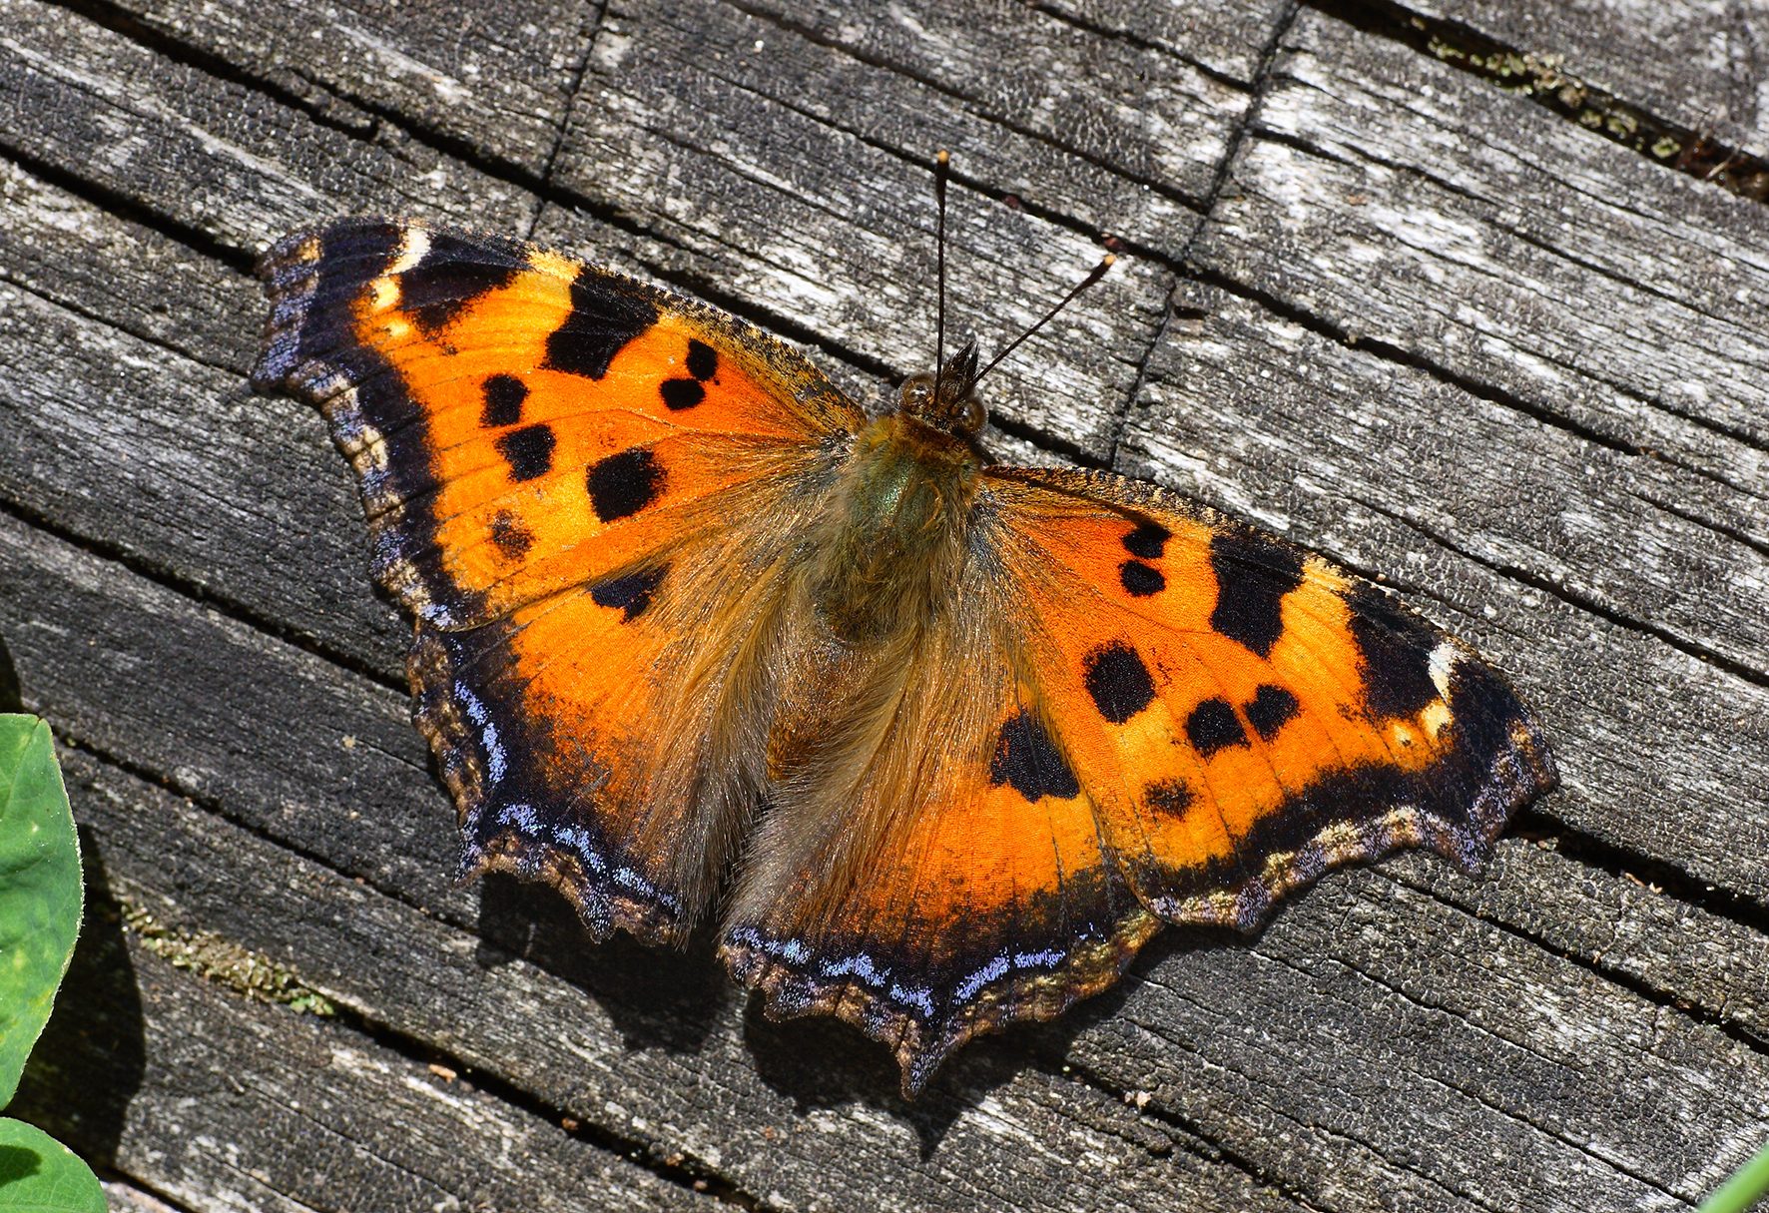
Figure 1 – Figure title (12 pt., not indented, centered alignment)
(empty string, 12 pt.)
Text, text, text… (12 pt., paragraph – 1.25 cm, justified alignment)
(empty string, 12 pt.)
References:
1. Ivanov V. 2013. The checklist of Belarusian spiders (Arachnida, Araneae) // Zoology and Ecology. Vol. 23. №. 4. P. 293–311.

